**Assignment 24.3**

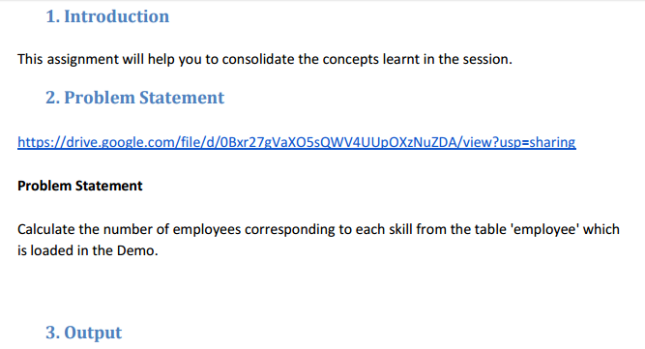

* First we will create table employee using create command where rows are delimited by ‘,’.



* Now we will load our data from local path to the table employee using load command



Now using select command we can show data of the table

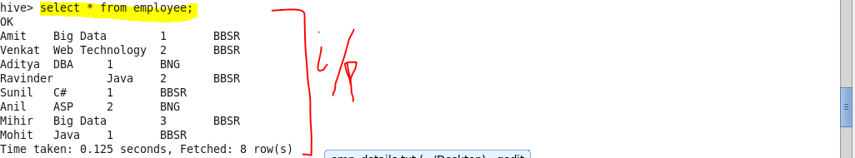

**Solution –**

* **We will select skills and the corresponding count of the names of employees that will show the number of total employees with particular skill and then we will group our result by skill.**

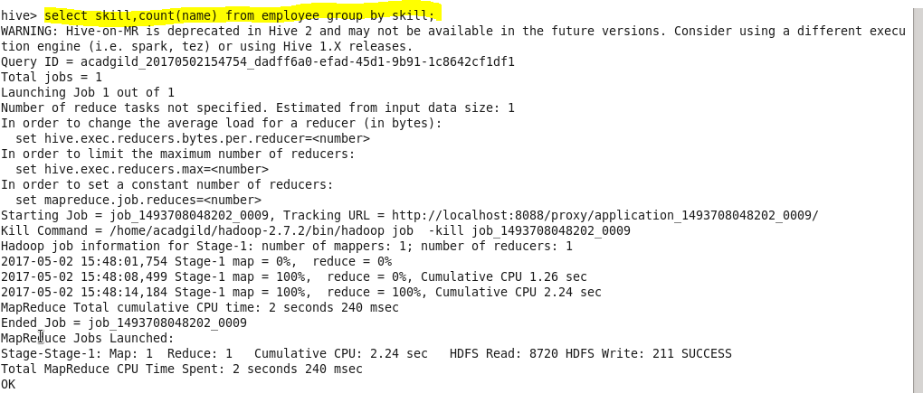

**Output**

**So following result shows the number of employees corresponding to skill.**

